Preview of Pre-Application Form
Click here to watch the video on how to submit applications.

This is the form for applicants to preview the Pre-Application questions and instructions to follow while completing the online form through the grant portal.
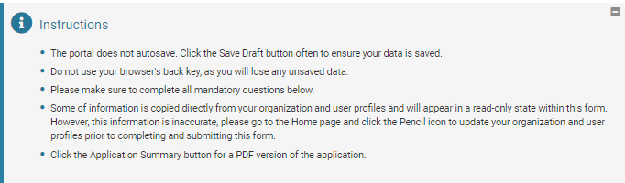
Tab: Pre-Application
Organization Contact Information
Pre-populates from the data under the Organization Profile. If you see changes should be updated, go to that menu and revise fields to reflect accurate Name, Address, Phone.

Primary Contact
Pre-populates from the data under the Personal Profile. If you see changes should be updated, go to that menu and revise fields to reflect accurate Name, Address, Phone, Email.

Request Amount (required)*
Request Title (required)*
Please list a title, not a description of the project. Maximum word count: 15 (Examples: Seniors Health Program or General Operating Support)

Program and Services (required)*
Without repeating what you included in the Organization Background field, please describe the program or programs for which you are requesting support. While the vast majority of our grants include a challenge element, please do not focus your request on your fundraising strategy. Rather, please focus your response on the program or programs for which you are seeking funding. Please include:
- A brief description of the program for which you are seeking support; and
- Goals of the program (including two to three measurable outcomes).

Description of Additional Programs (required)*
Aside from the program described above, please list up to three additional programs for which you are fundraising, starting with your first priority.

Click here to enter expenses
Organization and Program Expenses
Last Year Current Year
Total Organization Expenses $0.00 $0.00
Total Program Expenses $0.00 $0.00

Largest Organization Supporters (required)*
Please list your ten largest private organization supporters during the most recently completed fiscal year. For multi-year support, indicate the total amount of support on an annual basis. For multi-year support, indicate the total amount of support on an annual basis. Also note whether the support is project specific or for general operations. Please exclude in-kind donations. (EXAMPLE: ABC Foundation $20,000/yr for 3 years ($60,000 total, 2007-2009) - Program Specific: XYZ Program)

