Preview of Full Application Form
Click here to watch the video on how to submit applications.

This is the form for applicants to preview the Full Application questions and instructions to follow while completing the online form through the grant portal.
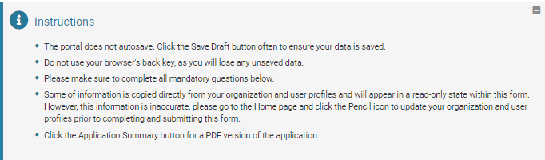

TAB: PRE-APPLICATION

Organization Contact Information
Pre-populates from the data under the Organization Profile. If you see changes should be updated, go to that menu and revise fields to reflect accurate Name, Address, Phone.

Primary Contact
Pre-populates from the data under the Personal Profile. If you see changes should be updated, go to that menu and revise fields to reflect accurate Name, Address, Phone, Email.

Request Amount (required)*
Request Title (required)*
Please list a title, not a description of the project. Maximum word count: 15 (Examples: Seniors Health Program or General Operating Support)

Program and Services (required)*
Without repeating what you included in the Organization Background field, please describe the program or programs for which you are requesting support. While the vast majority of our grants include a challenge element, please do not focus your request on your fundraising strategy. Rather, please focus your response on the program or programs for which you are seeking funding. Please include:
- A brief description of the program for which you are seeking support; and
- Goals of the program (including two to three measurable outcomes).

Description of Additional Programs (required)*
Aside from the program described above, please list up to three additional programs for which you are fundraising, starting with your first priority.

Organization and Program Expenses (required)*
Click here to enter expenses
Last Year Current Year
Total Organization Expenses $0.00 $0.00
Total Program Expenses $0.00 $0.00

Largest Organization Supporters (required)*
Please list your ten largest private organization supporters during the most recently completed fiscal year. For multi-year support, indicate the total amount of support on an annual basis. For multi-year support, indicate the total amount of support on an annual basis. Also note whether the support is project specific or for general operations. Please exclude in-kind donations. (EXAMPLE: ABC Foundation $20,000/yr for 3 years ($60,000 total, 2007-2009) - Program Specific: XYZ Program)

Tab: APPLICATION

Leadership Demographics (required)*
How does the board, staff, and leadership reflect the community your organization serves? If readily available, you are welcome, but not required, to include a breakdown of board and leadership demographics, backgrounds, experiences, etc.

Community Served (required)*
How does your organization involve the community and/or beneficiaries served in defining needs and opportunities and developing strategies and programs?

Significant Changes (required)*
Please explain any significant changes to your organization since your previous COSF grant request or since you submitted a Pre-Application (for example, changes to your programming, budget or staffing).

Outcomes and Lessons Learned (required)*
Please briefly describe the progress toward accomplishing the goals and desired outcomes of the program described in your prior grant request. Did you execute the program substantially as described in your prior grant request? Did you achieve what you set out to do? Was the program budget substantially the same as it was proposed? Please explain.

Request Summary (required)*
Please provide a brief (1 - 3 sentences) summary of your request. If you are requesting multi-year support, please include how much you are requesting for each year. Maximum word count: 50

Request Grant Term (required)*
How many months would you like this grant to cover?

Outcomes Chart (required)*
As part of our review process, the Circle of Service Foundation is particularly interested in understanding your programmatic goals and outcomes. We use our Outcomes Chart as a tool to collect this information. Please click here to download our Outcomes Chart, instructions and samples of how an organization might complete the chart. If you have questions or would like to discuss the chart before you submit your application, please contact your Program Staff.

Outcomes Tracking System (required)*
What software or systems do you use to track your outcomes?
Access | Altmetric | Apricot
Asana | AthenaHealth | AVATAR
CareFree | CaseWorthy | Cilsfirst
CitySpan | CiviCore | custom or proprietary database
Databank | Desire2Learn | DonorPerfect
EasyGrants | Efforts to Outcomes | Eventbrite
Excel | FileMaker | GE Centricity
Gradpro | Griffin | Griffin
Hands on Connect | HMIS (Homeless Management Information System) | HSMS (Human Services Management System)
iCarol | Infonet | Luminate Online
MCP Dashboard | Microsoft Dynamics | Mission Measurement
Mobilize | MPC Dashboard | Naviance
NeonCRM | OnCore | OpenBooks
Salesforce | SharePoint | Signal Vine
SPSS Statistics | SQL | Survey Monkey
Therap | Zoho | Other

Outcomes Tracking System Additional
If you use more than one software system, please enter what you use below.

Fundraising Priorities (required)*
If you have it, please provide specific information about your fundraising priorities such as:
- Increasing donors at the $500 and up levels
- Increasing your donor retention rate by X%
- Converting event donors to annual donors
- Increasing your total number of new donors by X%

How would you use the challenge grant to advance your fundraising priorities? Also, bearing in mind that it typically takes about 90 days for us to fully review a grant, are there any dates or deadlines in your fundraising strategies that you would want to utilize specifically in relation to a challenge grant? (required)*

Donor Management Software (required)*
Abila | Access | Blackbaud CRM
Blackbaud eTapestry | Blackbaud Luminate CRM | Blackbaud Raiser's Edge
custom/proprietary donor management system | DonorPerfect | Excel
Fund EZ | GiftWorks | Griffin
Little Green Light | Neon | OvationTix
Quickbooks | ResultsPlus | Salesforce
Salsa | Tessitura | Total Info
Other

* If you selected Other, please enter what you use below

Would you need to do anything differently with your current donor management system in order to track new and increased giving for a challenge grant? (required)*

Tab: BOARD OF DIRECTORS

Board of Directors (required)*
How many people served on your board of directors in the most recently completed fiscal year?

What was the total amount personally contributed by the board for the most recently completed fiscal year? (required)*
Contributions through board member personal trusts, family foundations, or donor advised funds may be included if the individual board member personally contributed the funds held by the trust, foundation, or donor advised fund. Please exclude all value of in-kind goods or services.

Board of Directors Personal Cash Gift (required)*
How many board members gave a personal cash gift in the most recently completed fiscal year?

What was the lowest amount of personal giving from the board? (required)*
Please list the lowest amount - no names are needed.

What was the highest amount of personal giving from the board? (required)*
Please list the highest amount - no names are needed.

Board Giving Notes (required)*
If you had less than 100% board giving in the most recently completed year, please explain why. Please also comment on board giving for the current fiscal year.

What was the total amount raised by the board for the most recently completed fiscal year? (required)*
Please exclude all personal board member contributions and the value of in-kind goods or services.

How many board members fundraised in the most recently completed fiscal year? (required)*

What was the lowest amount raised by board members? (required)*
Please provide lowest amount raised - no name needed.

What was the highest amount raised by board members? (required)*
Please provide highest amount raised - no name needed.

What is the minimum "give or get" obligation for each board member, if applicable? (required)*
If this is not required, please respond "0".

Other Board Notes (required)*
Please include information about any other boards operating at the organization (e.g. local advisory board, junior board, auxiliary board, etc. You may also use this space for any additional notes you'd like to share about your board.

Fiscal Year End Date (required)*
When did your last fiscal year end?
MM/DD/YYYY

Tab: REVENUE AND EXPENESES
Budget (required)*

Click here to enter the budget

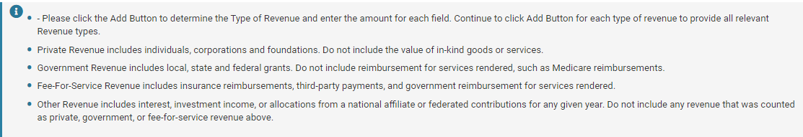
Organization Revenues
Type of Revenue Revenue Last Year Revenue Current Year Revenue Next Year
Private Revenue $0.00 $0.00 $0.00
Government Revenue $0.00 $0.00 $0.00
Other Revenue $0.00 $0.00 $0.00
Fee-For-Service Revenue $0.00 $0.00 $0.00
$0.00 $0.00 $0.00

Expenses
Total Expenses Last Year Total Expenses Current Year Total Expenses Next Year
Total $0.00 $0.00 $0.00

Surplus/Deficit
Surplus/Deficit Last Year Surplus/Deficit Current Year Surplus/Deficit Next Year
Total $0.00 $0.00 $0.00

Net Assets
Net Assets Last Year Net Assets Current Year Net Assets Next Year
Total $0.00 $0.00 $0.00

Program Revenues
Type of Program Revenue Program Revenue Last Year Program Revenue Current Year Program Revenue Next Year
Program Private Revenue $0.00 $0.00 $0.00
Program Government Revenue $0.00 $0.00 $0.00
Program Other Revenue $0.00 $0.00 $0.00
Program Fee-For-Service Revenue $0.00 $0.00 $0.00
$0.00 $0.00 $0.00

Program Expenses
Program Total Expenses Program Total Expenses Program Total Expenses
Last Year Current Year Next Year
Total $0.00 $0.00 $0.00

Program Surplus/Deficit
Program Surplus/Deficit Program Surplus/Deficit Program Surplus/Deficit
Last Year Current Year Next Year
Total $0.00 $0.00 $0.00

Revenue Notes
Please explain if any of the Other Revenue amounts above are more than 3% of total revenue for that fiscal year. You may also use this field for additional information you would like to share regarding revenue.

Major Supporters
Please list your ten largest private organization supporters during the last fiscal year. For multi-year support, indicate the total amount of support on an annual basis. (EXAMPLE: XYZ Foundation $20,000/yr for 3 years ($60,000 total, 2017-2019)) Also note whether the support is project specific or for general operations. Please exclude in-kind donations.
Surplus/Deficit

Deficit Notes
If the organization has recently experienced or is currently anticipating a deficit, please explain what has contributed to the situation and how the deficit will be reduced/eliminated. Also, the Surplus/Deficit amounts should be equal to the Total Revenue amounts listed above minus the Total Expenses amounts listed above. If this is not the case, please explain.
Net Assets

Salary Information
Please provide the titles and salaries for the organization's five highest-paid employees and the number of years at the current position. If any of these five positions have been filled for less than a year, please list the previous salary and the number of years in the position. If your organization operates nationally, please provide national staff salary information. We may request the local staff information during our review process.

Program Total Revenue

Program Revenue Notes
Please explain if any of the Other Revenue amounts above are more than 3% of total revenue for the
requested program for that fiscal year. You may also use this field for additional information you would like to share regarding revenue.

Program Major Supporters
Please list your ten largest private organization supporters of the program for which you are seeking funding during the last fiscal year. For multi-year support, indicate the total amount of support on an annual basis. (EXAMPLE: XYZ Foundation $20,000/yr for 3 years ($60,000 total, 2017-2019)) Also note whether the support is project specific or for general operations. Please exclude in-kind donations.

Program Surplus/Deficit

Program Deficit Notes
If the program has recently experienced or is currently anticipating a deficit, please explain what has
contributed to the situation and how the deficit will be reduced/eliminated.

Tab: ATTACHMENTS

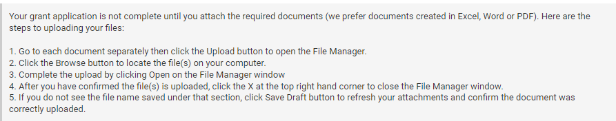

Board of Directors List (required)*
Please show any other corporate and/or organizational affiliations and terms of service. Please also list or otherwise indicate each committee on which each board member serves (such as Executive, Finance and Development). If you have an advisory board, junior board, etc. please include that list as well.

Financial Statements (required)*
Please provide your financial statements for the most recently completed fiscal year. If the audit of those statements is not complete, please provide both the unaudited financial statements for the most recently completed fiscal year and the most recently audited financial statements. If your audited financial statements are not available electronically, please mail or fax a copy.

Organization Budget (required)*
Please provide the current fiscal year budget for your entire organization. Please include both budgeted
amounts as well as year to date actual revenue and expenditures.

Program Budget
If you are seeking funding for a specific program, please provide the current fiscal year budget for that
program. Please include both budgeted amounts as well as year to date actual revenue and expenditures.

Other
If you have other supporting documents that you would like us to consider, you may attach them with the drop-down title "Other" below.

